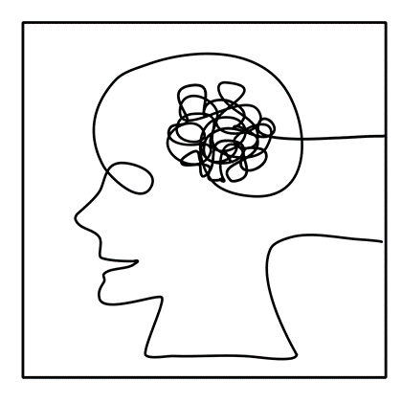

Table of Contents

**Creation of our Game** 3

Team information 3

Introduction 4

**Work plan** 5

Completion Tasks 5

Team information

Introduction

|  |
| --- |
| Introduction |
| What is the type of the project?  The project is a Game, made with C++ (Cpp). |
| What is its concept?  The game contains questions and answers in the form of trivia. |
| What is the purpose of it?  The goal of the game is to give as many correct answers as possible and have as high a score as possible. |
| What did we use to make it?  We used Git/GitHub, Visual Studio 2022, Microsoft Teams, Discord, Microsoft Word, PowerPoint, Google and Cmd. |

Completion Tasks

|  |  |
| --- | --- |
| № | Task Breakdown |
| 1 | **Tasks and deadlines**  Our Scrum Trainer has assigned our team tasks to complete the project on time. |
| 2 | **Creating the basics of the code**  The basics of the code are created by our Backend Developer. |
| 3 | **Coming up with the idea**  Everyone on the team gets involved in coming up with idea. |
| 4 | **Looking for information on the tools needed to make the code**  Our Backend and Frontend did that. |
| 5 | **Quality Insurance**  Our QA created unit-test files in Visual Studio and ran them with parts of our code. |
| 6 | **Clear the errors**  All of the team gets involved in that. |
| 7 | **Documentation**  The documentation was written by our Scrum Trainer and Designer to summarize everything related to the site. |
| 8 | **Presentation**  The presentation was created by our Backend and Designer. |